TOPIC 11: Forensics

Worksheet 11.1

How observant are you?
Answers
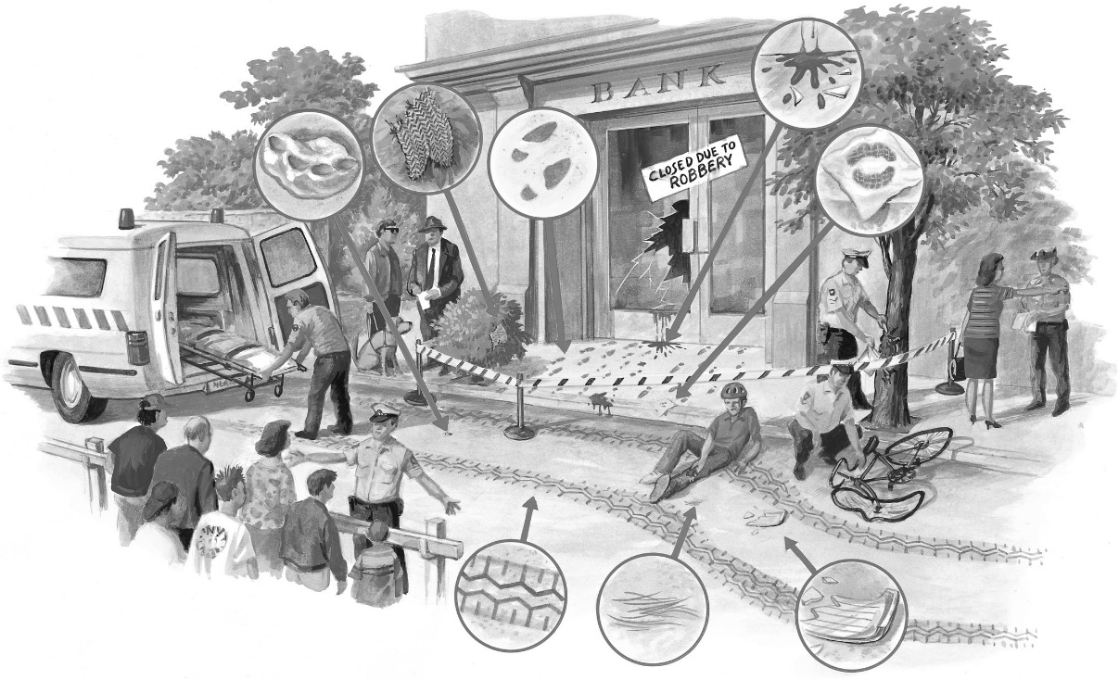
Examine the crime scene above.

1. List the evidence that you can observe in the diagram.
Teeth marks on chewing gum, a torn piece of clothing, footprints, blood, lip print, a broken car headlight, hair, tyre prints

2. What other types of evidence could be taken?
Photographs, eyewitness accounts, CCT footage

3. Use the evidence you have observed to build up a story about what might have happened.
Students’ answers will vary, but may include: a male and/or female bank robber, the getaway car has hit a cyclist and the car has been damaged, and the bank robbers may be injured.

4. What conclusions can you make about the perpetrator(s)?
The perpetrators may include a male and a female. They may be driving a damaged car and may be injured.

